# Assignment No:3

Practical Exercise: Image Classification using Convolutional Neural Networks (CNNs) for Multiclass Classification

## 1) Problem Statement

Implement image classification using Convolutional Neural Networks (CNNs) to classify images from the CIFAR-10 dataset into 10 different categories. The model should be able to learn from the training set and classify unseen test images.

## 2) Libraries Used

Python:  
1. **TensorFlow/Keras**: For building and training the Convolutional Neural Network (CNN) model.  
2. **Matplotlib**: For visualizing the dataset and results.  
3. **NumPy**: For array manipulation and preprocessing.

## 3) Theory

Convolutional Neural Networks (CNNs) are specialized neural networks designed to process and classify images. They are particularly effective for image data due to their ability to capture spatial hierarchies in images through convolutional layers. The CIFAR-10 dataset consists of 60,000 32x32 pixel images across 10 categories (e.g., airplanes, cars, birds, cats, etc.).  
  
CNNs use a combination of convolutional layers, pooling layers, and fully connected layers to learn patterns and features in images. The convolutional layers apply filters to capture local features, while pooling layers down-sample the image, reducing its dimensionality. The final layers are fully connected and used for classification.

## 4) Methods

1. **Data Preprocessing**:  
 - The CIFAR-10 dataset is loaded, and the images are normalized to have pixel values between 0 and 1.  
 - The dataset is split into training and test sets.  
   
2. **Model Architecture**:  
 - The CNN model consists of multiple convolutional layers followed by max-pooling layers.  
 - After the convolutional layers, the output is flattened and passed through fully connected layers.  
 - The output layer consists of 10 neurons (one for each class) with softmax activation to predict the class probabilities.  
  
3. **Training**:  
 - The model is trained using the Adam optimizer and categorical crossentropy loss function.  
 - The model is evaluated on the test set to measure its accuracy and generalization performance.  
  
4. **Evaluation and Results**:  
 - The model's performance is evaluated using accuracy metrics, and sample images with their predicted labels are visualized.

## 5) Advantages and Disadvantages

- **Advantages**:  
 - CNNs are highly effective for image classification tasks due to their ability to learn spatial hierarchies in images.  
 - TensorFlow/Keras provides easy-to-use APIs for building, training, and evaluating CNNs.  
   
- **Disadvantages**:  
 - CNNs require large amounts of labeled data to train effectively.  
 - Training deep CNNs can be computationally expensive, requiring powerful hardware like GPUs.

## 6) Diagram

## CNN architecture for multi-class classification. | Download Scientific Diagram

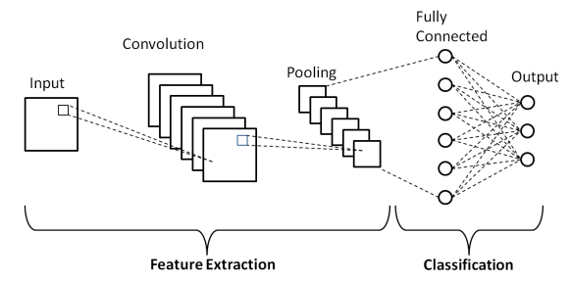

## 7) Conclusion

Convolutional Neural Networks (CNNs) provide a powerful tool for solving multiclass image classification problems. By leveraging convolutional layers and pooling layers, CNNs are able to capture complex patterns in images, making them highly effective for tasks such as classifying images from the CIFAR-10 dataset. The model's performance can be further improved with techniques like data augmentation and deeper architectures.